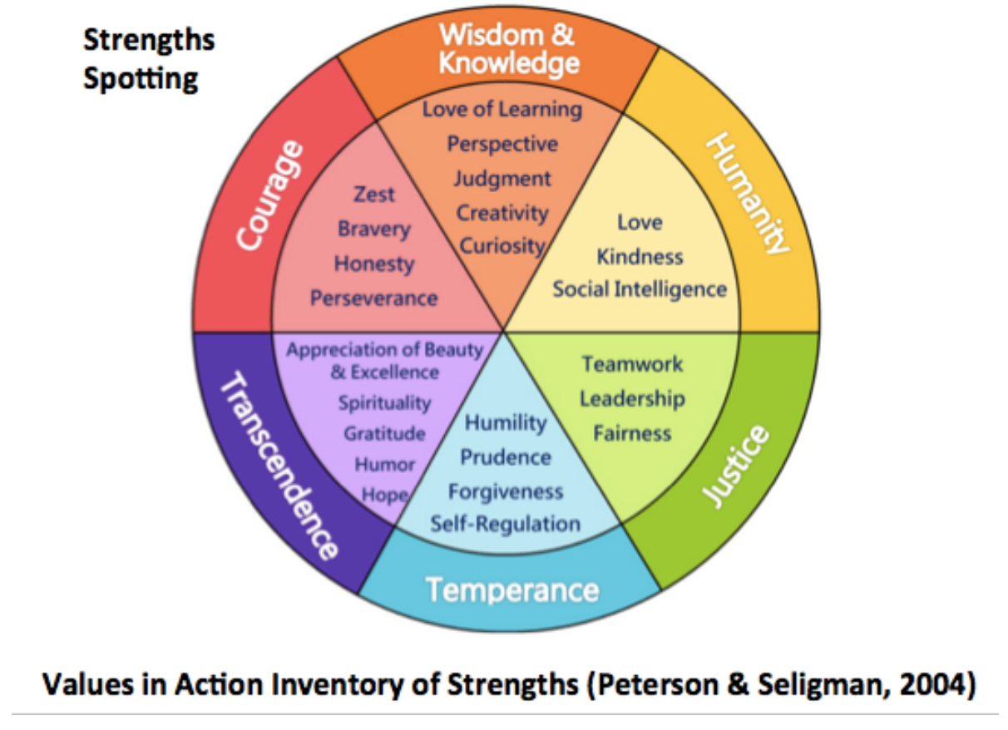
Dr. Cheryl Caesar WRA 1004 / 0102
Fall 2019
Office: 241 Bessey Hall
Email: caesarc@msu.edu
Phone: 884-7694
Office hours: M/W 12:30 - 2:30 PM and by appt.
Class meetings:
Section 001:
M/W 8:30-9:50, 106 Bessey
F 8:00-9:50, 211 Bessey and online
Section 002:
M/W 10:20-11:40, 222 Bessey
F 10:20-12:10, 211 Bessey and online

Image:Positive Psychology News

Preparation for College Writing
Theme: Writing for Wellness /
Cultivating Positive Habits of Mind

Course Overview
Since 1952, the American Psychiatric Association. has published, and periodically updated, the Diagnostic and Statistical Manual, which is a catalogue of all the agreed-upon categories of mental disorder. In 1999, psychologist and philanthropist Neal Mayerson and Martin Seligman, founder of the school of “positive psychology,” founded the Mayerson Foundation, which went on to create the Values in Action Institute. This school of thought believes that humans can find fulfillment and lead satisfying lives not only by seeking to cure illnesses, but by studying and cultivating strengths of character and positive habits of mind. These are compiled in a manual called Character Strengths and Virtues: A Handbook and Classification Peterson and Seligman, 2004). The writers of the book looked for human characteristics that are admired in every culture -- eastern and western; secular and religious: wisdom, courage, humanity, justice, temperance and transcendence. They then broke these down into a group of more specific traits that make up the larger one. For example, wisdom consists of creativity, curiosity, judgment, love of learning and perspective.

This research has been widely used not only in the field of psychology, but also in education. Writers’ groups and writing classes have discovered that by writing our stories illustrating a character strength, we develop an awareness of that strength and help it grow. We also build positive associations with writing and come to enjoy it more.

This is what we will be doing in this class: studying universal character strengths first in our own lives (the personal learning narrative) and then as expressed in a cultural artifact, a traditional story from each student’s culture. We will compare, contrast and analyze these stories. Third, we’ll form groups to create a multimedia project to present the stories and our analyses to other classes at the First-Year Writing Symposium. And finally we will reflect on the semester’s learning and write a letter of gratitude to someone who has been influential in our lives.

Course Expectations
I expect our class to become a supportive learning community as we practice writing, peer review and revision, small-group work, discussions and presentations (culminating in presentations to other classes at the First-Year Writing Symposium at the end of the semester.
To succeed in this course, and get the most out of it, choose to stay interested and engaged. Come to every class. Come prepared and on time (but if an emergency strikes, by all means come late/unprepared rather than not at all). Speak up. Share your questions, your comments, your suggestions, your concerns. (If you prefer not to do this in class, come to my office hours or send me an email.) Listen respectfully to your classmates. Read their work attentively, and respond with helpful feedback. (We will practice ways to do this.)

Expect any college class to require a minimum of 2 hours of preparation (studying, reading, writing, peer review, group projects, etc.) per week per credit hour. WRA 1004-0102 is a three-credit class, so plan to spend at least 6 hours weekly on preparation. This need not always be solitary studying, but will include pairwork and small group work. You are encouraged to make use of my office hours, the Writing Center, the ESL Lab (international students) and the MSU Libraries (in person and online.)

You can expect to receive full explanations of our assignments, their rhetorical and pedagogical purposes, and their grading criteria. (If something is not clear, please keep asking till it is.) You can expect thoughtful responses to your work, both in writing and in face-to-face conferences, and opportunities to improve it. You can expect that I will always be on time and prepared for classes and for office hours – or, if prevented by illness or other emergency, I will notify you immediately. If you cannot come to regular office hours, we will find another time to meet. And you can expect that I will read and respond to your email messages within 24 hours (although your work should be submitted on Eli and D2L, not as an email attachment). Please facilitate a prompt response by putting your name at the end of your message, and the subject in the Subject box.

If you would like to know more about me, my background and my interests, feel free to visit my MSU website.

Assignments and Assessment
We will have four major assignments:

Assignment 1: personal learning narrative 15% of semester grade;
Assignment 2: cultural literacies:
intercultural comparison of traditional stories 20%;
Assignment 3: 25%
remix assignment and Symposium presentation
with learning reflection
Assignment 4: semester learning reflection 20%;
Weekly journal writing (effort-based) 20%.

Total 100%

There will be no final exam, but I will be available for optional office hours during the scheduled final exam period.

Because Tier 1 writing classes are active-learning environments, they require steady attendance. We allow three absences for illness, emergencies, family events, religious holidays, etc. (Of course, you are still required to find out what we did in class and stay up to date with your work.) After three absences, each additional absence accrues a penalty of 0.2 to your semester grade. Consistent lateness is also detrimental to your learning experience, and therefore, frequent late arrivals will be reflected in your Participation grade.

The computer lab sessions on Friday (WRA 0102) will be online classes on the following dates: 8.30, 10.4, 10.18, 11.1, 11.13 and 11.15. On these days you do not have to come to the computer lab (although that space will be available to you). You may do the class wherever you wish, as long as you complete all the work by midnight on that day.

If you wish to enhance your grade with extra-credit points, you may attend a campus or local event of cultural interest, take photographs and field notes and present it to your classmates. Each presentation adds 0.2 to your semester grade, and you may do up to three of them. Events will be posted on the D2L Calendar; please feel free to suggest any others that you hear of.

Course Materials
Please bring your laptop or tablet to each class each day, and also paper and pencil or pen.

MSU First-Year Writing Program (Tier 1)
MSU Tier 1 writing courses are based on the learning goals of inquiry, discovery and communication. As our WRAC department website notes, “FYW classes are different from many other University classes, in that they are oriented to practice. Your FYW class will be smaller, more personal, more activity-oriented, and more collaborative than most of your other classes—your job as a student in it won’t be to listen to lectures and take notes, but to practice writing processes and strategies. You can expect to learn new things, and to be given space to do so.”
The First-Year Writing learning goals support all five of the MSU Liberal Learning Outcomes and Global Competencies: analytical thinking; cultural understanding; effective citizenship; effective communication and integrated reasoning.

Online SIRS
Michigan State University takes seriously the opinion of students in the evaluation of the effectiveness of instruction, and has implemented the SIRS (Student Instructional Rating System) process to gather student feedback. This course utilizes the "online SIRS" system. You will receive an e-mail sometime during the last two weeks of class asking you to fill out the SIRS online form at your convenience. Please note the final grade for this course will not be accessible on STUINFO for seven days following the University grade submission deadline published by the Office of the Registrar unless the SIRS online form has been filled out. You will have the option in the online SIRS form to decline to participate in the evaluation of the course - we hope, however, that you will be willing to give us your frank and constructive feedback so that we may instruct students even better in the future.

MSU Student Rights and Responsibilities
For detailed information on these, see Office of the University Ombudsperson.
“The Office of the University Ombudsperson is available to assist students with any conflict or problem that has to do with being a student at MSU. You may visit the Ombudsperson in 129 North Kedzie, call (517) 353-8830 or e-mail ombud@msu.edu. The Office of the University Ombudsperson is an independent, neutral, informal and confidential resource and does not accept formal complaints, nor does it provide notice to the University.”

The Spartan Code of Honor Academic Pledge
“​As a Spartan, I will strive to uphold values of the highest ethical standard. I will practice honesty in my work, foster honesty in my peers, and take pride in knowing that honor in ownership is worth more than grades. I will carry these values beyond my time as a student at Michigan State University, continuing the endeavor to build personal integrity in all that I do.​”

For more information on university policies of academic honesty, see Academic Integrity at MSU.

Campus Climate, Diversity and Inclusion
“MSU welcomes a full spectrum of experiences, viewpoints, and intellectual approaches because they enrich the conversation, even as they challenge us to think differently and grow. However, we believe that expressions and actions that demean individuals or groups compromise the environment for intellectual growth and undermine the social fabric on which the community is based” (“Embracing Perspectives and Diversity”).

Michigan State University is committed to providing equal opportunity for participation in all programs, services and activities. Requests for accommodations by persons with disabilities may be made by contacting the Resource Center for Persons with Disabilities at 517-884-RCPD or on the web at rcpd.msu.edu. Once your eligibility for an accommodation has been determined, you will be issued a verified individual services accommodation (“VISA”) form. Please present this form to me at the start of the term and/or two weeks prior to the accommodation date (test, project, etc). Requests received after this date will be honored whenever possible.

Title IX Protections: "Michigan State University is committed to fostering a culture of caring and respect that is free of relationship violence and sexual misconduct, and to ensuring that all affected individuals have access to services. For information on reporting options, confidential advocacy and support resources, university policies and procedures, or how to make a difference on campus, visit the Title IX website.

“Limits to Confidentiality: Essays, journals, and other materials submitted for this class are generally considered confidential pursuant to the University’s student record policies. However, students should be aware that University employees, including instructors, may not be able to maintain confidentiality when it conflicts with their responsibility to report certain issues based on external legal obligations or that relate to the health and safety of MSU community members and others. As the instructor, I must report the following information to other University offices if you share it with me:
● Suspected child abuse/neglect, even if this maltreatment happened when you were a child,
● Allegations of sexual assault or sexual harassment when they involve MSU students, faculty, or staff, and
● Credible threats of harm to oneself or to others.
These reports may trigger contact from a campus official who will want to talk with you about the incident that you have shared. In almost all cases, it will be your decision whether you wish to speak with that individual. If you would like to talk about these events in a more confidential setting you are encouraged to make an appointment with the MSU Counseling Center.”

International Student & Scholar Support Program
Studying in another country is an exciting life experience. It can also be a time of change, adjustment, and stress.
MSU has made available International Student Support Program (ISSP) services from Morneau Shepell for International students and scholars at MSU and for MSU students in Education Abroad programs. ISSP is free to use, and your information is kept private. In addition to one-on-one support, you have access to articles, tools, and resources that can help you succeed.
The International Student Support Advisors can help anytime with:
● adapting to new cultures
● being successful at school
● relationships with friends and family
● practical issues while studying abroad
● stress, sadness, loneliness and much more
What makes ISSP special is that you can connect with an Advisor who:
● speaks your language
● understands your culture
● keeps all information confidential, and
● is available 24/7 at no cost to MSU students!
ISSP support can be accessed in any of the following ways:
● by mobile and web chat
● over the phone
● through video.

Most important: Welcome to this class! I hope it will be a fruitful, enjoyable and memorable place for you to learn and grow.

PCW Calendar FS19

The deadlines for major assignments will be listed from the beginning of the semester, but class activities will be added as the semester progresses, according to the class’s needs and campus opportunities. Keep watching this space, and our home page on D2L.
Week 1
W 8.28.19 Icebreaker with index cards
Syllabus and assignments
Distribute Side by Side.
Homework:
D2L tutorial and profile.
F, 8.30.19 Online class: professor at Advisory Council
Write response to SbS story.

Week 2
M, 9.2.19 Labor Day
W, 9.4.19 Discuss F writings.
More about First-Year Writing.
F, 9.6. 19 Show and explain the Character Strengths and Virtues
Handbook.
Watch Mayerson video, take survey; write in response to findings.
Sign up for Eli.
Do one cycle of write, review, revise, using M writing.
Homework: Do Eli tutorials and note questions.
Start journal. Write about courage.

Week 3
M, 9.9.19 Response to Eli and D2L questions.
Intro to A1. Focus on: courage.
Discuss 4 VIA components: bravery, honesty, perseverance,
zest.
Today: bravery. New York Times readings & discussion.
W, 9.11.19 Honesty.
F, 9.13.19 Perseverance and zest.
Reflection on courage in journal.
Upcoming week: write in journal about zest and
perseverance.
Homework: first draft Assignment 1.

Week 4
M, 9.16.19 Peer review 1st drafts.
Intro to Writing Center.
W, 9.18.19 Revision Plan 1st drafts.
F, 9.20.19 Assessing A1
Signups up WeJoinIn for A1 conferences.

Week 5
M, 9.23.19 Cover letter for A1
T-Th, 9.24-6.19 Individual student conferences for A1
F, 9.27.19 Peer review and revision of A1
Write in journal about humanity.
Sun. 9.29.19 Final draft due at midnight on Eli.

Week 6
M, 9.30.19 Introduction to A2:
the intercultural comparison of traditional stories
Add: virtues of humanity.
W, 10.2.19 Reading: feminist interpretation of “Cinderella.”
F, 10.4.19 Online class: professor at Advisory Council.

Week 7
M, 10.7.19 Focus on: wisdom.
W, 10.9.19 Library: orientation and research for A2
F, 10.11.19 Bettelheim: psychoanalytic reading of “Cinderella.”

Week 8
M, 10.14.19 A2: from focus to draft
W, 10.16.29 A2: polishing draft with RP and RP
F, 10.18.19 Online class: professor at Conference on Community Writing
Week 9
M, 10.21.19 Assessing A2
W, 10.23.19 Individual student conferences for A2
F, 10.25.19 Peer review and revision for A2

Week 10
M, 10.28.19 Intro to A3, the Remix
Focus on virtue of justice.
W, 10.30.19 Work on Remixes: team building and maintenance.
F, 11.1.19 Idem.

Week 11
M, 11.4.19 Work on Remixes: team building and maintenance.
W, 11.6.19 Idem.
F, 11.8.19 Idem.

Week 12
M, 11.11.19 Prepare for Learning Abroad Conference
W, 11.13.19 Video: effective public speaking. Professor away at
conference.
F, 11.15.19 Learning Abroad Conference. Professor away at
conference.

Week 13
M, 11.18.19 Present Remixes to classmates
W, 11.20.19 Idem.
F, 11.22.19 First-Year Writing Symposium

Week 14
M, 11.25.19 Reflect on FYWS.
Gratitude haiku.
Intro to A4, the semester reflection: letter of gratitude.
Focus on virtues of transcendence.
W, 11.27.19 Work on A4: focus and development.
F, 11.29.19 No class: Thanksgiving holiday
Share A4 with recipient.
Week 15
M, 12.2.19 Semester learning reflection. Focus on: wisdom.
W, 12.4.19 Semester learning reflection: PR and RP.
F, 12.6.19 Optional work session in computer lab:
polish A4; complete late works, revisions and makeups.
All work and makeups due at midnight.

Official final exam dates:
001: Monday, Dec 9 2019 7:45am - 9:45am in 106 Ernst Bessey Hall
002: Friday, Dec 13 2019 7:45am - 9:45am in 222 Ernst Bessey Hall

No final exam. Open office hours.

